

KANSAS RIB RUN RALLY
SEPTEMBER 26, 2026 - 8:00 AM – 2:00 PM

NO RALLY EXPERIENCE IS REQUIRED!

The Fourth Annual Kansas Rib Run Rally, a time-speed-distance (TSD) Rally sponsored by the Kansas City Triumphs Sport Car Club, will be held on Saturday, September 26, 2026.

The Rally will start at Olde Mill Properties also known as The Fuel House at 611 W 2nd St, Bonner Springs, KS 66012. The Fuel House will offer a limited breakfast menu starting at 7:00 AM. Arrive by 8:00 AM for check-in and orientation. The first car will be off on the Rally route at 9:01 AM. The 120-mile Rally route will wind its way through Linwood, Tonganoxie, and Leavenworth to a rest break in Atchison. Following the break, the Rally route will cross the Missouri River and follow the hilly and twisty roads to Weston, Missouri. The final section will lead participants back across the Missouri River to Bonner Springs and The Fuel House where the Rally will end. A BBQ lunch can be purchased from Quentin’s BBQ & Sides, along with a fine adult beverage from the Outfield Beer Company. All Rally participants and families are invited to eat and drink at The Fuel House.

The entry fee is $35 per car and is open to ONLY classic British & European cars built before 1986. In the past the Rally was only open to classic British cars. Registration will be in the order payment is received up to an overall total of 38 cars. Please be advised there are NO refunds after August 31. All vehicles registered will receive a dash plaque and awards will be given for first, second and third place.

Each entry will consist of a driver and a navigator, who will receive written general turn-by-turn instructions, and speed information. The Competitor – Richta GPS Checkpoints App (richtarally.com), available free from your app store downloaded to your navigator’s smartphone, is required. A working speedometer, odometer, smartphone charger or power pack and writing materials are highly recommended. The Richta Rally Apps allows the rally organizers to monitor the progress of each team, automatically score each vehicle’s time between checkpoints, and compute and display the score of each team.

In the event of a breakdown, tail vehicles will follow to provide assistance.

KANSAS RIB RUN RALLY
SEPTEMBER 26, 2026 - 8:00 AM – 2:00 PM

REGISTRATION FORM

DRIVER’S NAME (please print): PHONE:
ADDRESS:
CITY, STATE, ZIP:
EMAIL ADDRESS:

NAVAGATOR’S NAME (please print): PHONE:
ADDRESS:
CITY, STATE, ZIP:
EMAIL ADDRESS:

VEHICLE YEAR _______ MAKE ___________________MODEL ______________ COLOR _________

Note - The driver may register a vehicle without listing a navigator at this time. However, a navigator is required to compete in the Rally and must register and sign the Hold Harmless Agreement at check-in.

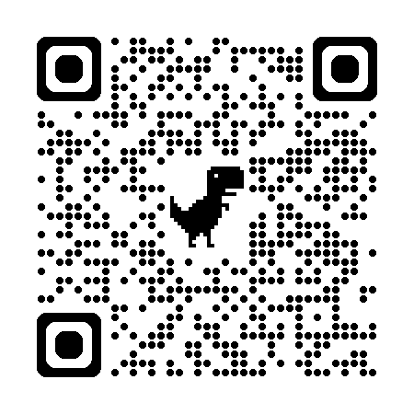
Registration is $35 per car. Make checks payable to KCTSCC and mail it with this signed registration form to Dan Sullivan, KCTSCC Treasurer, 16936 W 168th Terrace, Olathe, KS 66062

Or, to pay online click here or scan the QR code and email the signed registration to hawkeyesully@gmail.com or mail it to the address above.

Hold Harmless Agreement

The Driver and Navigator (“Participants”) voluntarily enter their vehicle in the 2026 Kansas Rib Run Rally, and affirm and agree to the following: (1) that vehicle owner has adequate insurance on their vehicle against loss that is in in full force and effect;.(2) that they have adequate medical and health insurance to cover any medical assistance that may be required; (3).that they do, hereby, agree to indemnify and hold harmless Kansas City Triumphs Sports Car Club and its officers, volunteers, agents or assigns, the owners and lessees of the premises used to conduct the event for any and all liability including acts or omissions which may result in the damage, destruction, or injury occurring during, or as a consequence of this event; (4) the Participants in attending this event, do so voluntarily and agree and assume the risk of any and all damage to their vehicle or personal injury.

Driver’s Signature ______________________________________________________________________ Date ________________

Navigator’s Signature _________________________________________________________________ __ Date________________

Vehicle insured with _________________________________________________________________________________________

